LanguageCert Test of English (LTE) Speaking
Discount/promo code: 393E8E (for students registering in Poland)
C4163A (for students registering outside Poland)

Speaking English and effectively communicating with others is the most important skill in the world. All your knowledge will not show to the world unless you can talk about it in English language.
Important: LanguageCert LTE Certificates are valid for life, they do not have an expiry date!
LanguageCert LTE A1-C2 Exam:
- Designed specifically for university students approaching graduation and entering the workforce.
- Valid for life, does not expire!
- Offers Office English certification, which is essential for professionals in today's globalized job market.
- Available online, with the convenience and comfort of online administration, ensuring security and privacy.
- Adaptive in nature, providing a personalized experience that assesses your current level of knowledge and potential for growth.
- International recognition of your language skills, which can enhance your academic and professional career prospects.
- Demonstrates to employers your commitment to improving your language skills, making you a valuable asset in the job market.
- Enhances your confidence in using English in the workplace, allowing you to communicate effectively with colleagues and clients from around the world.
So, if you're a university student looking to boost your career prospects, consider taking the LanguageCert LTE A1-C2 Exam to demonstrate your language skills and set yourself apart in the job market!
Use this promo code to register with a discount, you can redeem the discount anywhere in the world!
Discount/promo code: 393E8E (for students registering in Poland)
C4163A (for students registering outside Poland)

Book your secure, online exam here: https://www.languagecert.org/en/language-exams/english/languagecert-test-of-english-lte/a1-c2-speaking

EXAM STRUCTURE AND MAIN FEATURES
LTE Speaking is an approximately 15-minute interview between the candidate and the interlocutor who will ask you questions to allow you to show your maximum speaking performance. The interlocutor will not be the one deciding on your level and number of points you will be awarded, your Speaking exam will be evaluated by a different team at LanguageCert.
During the exam interview you will be asked questions with increasing level of difficulty, from your name and its spelling to expressing your views and opinions on different subjects and discussing general and office related topics.

APPLICATION of the LTE A1-C2 exam, why take LTE
LanguageCert Test of English (LTE) certificate will get you invited into a job interview faster! Recruiters from all over the world trust LanguageCert certifications and having any Certificate in your portfolio is always better than any ‘declaration’ of your English knowledge. Speaking in the English language is a very important skill at every turn of your academic and professional career.

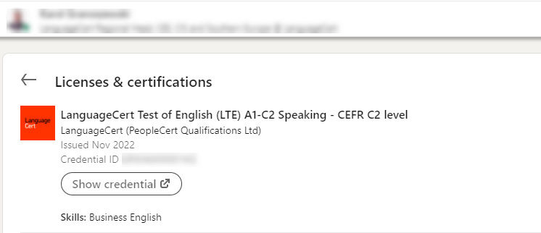

Help recruiters find and recruit you faster! LTE was designed to prove your ‘English survival skills’ in a working environment. You always pass the exam, your score is determined by your correct answers in a very modern, adaptive test format.

HOW TO REDEEM YOUR DISCOUNT/PROMO CODE

Discount/promo code: 393E8E (for students registering in Poland)
C4163A (for students registering outside Poland)
Book your secure, online exam here: https://www.languagecert.org/en/language-exams/english/languagecert-test-of-english-lte/a1-c2-speaking
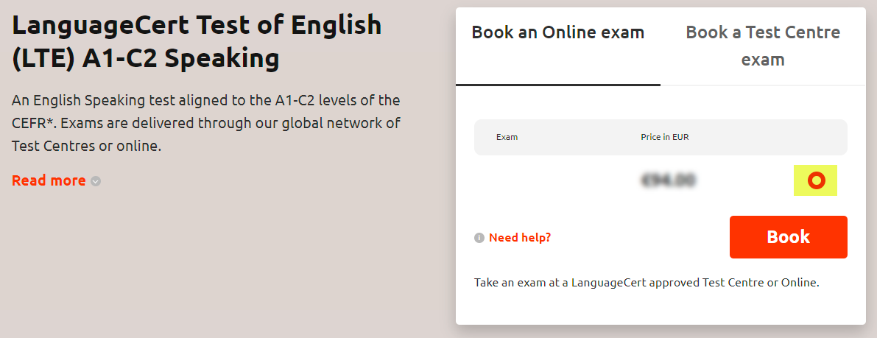
Select the red dot and click Book
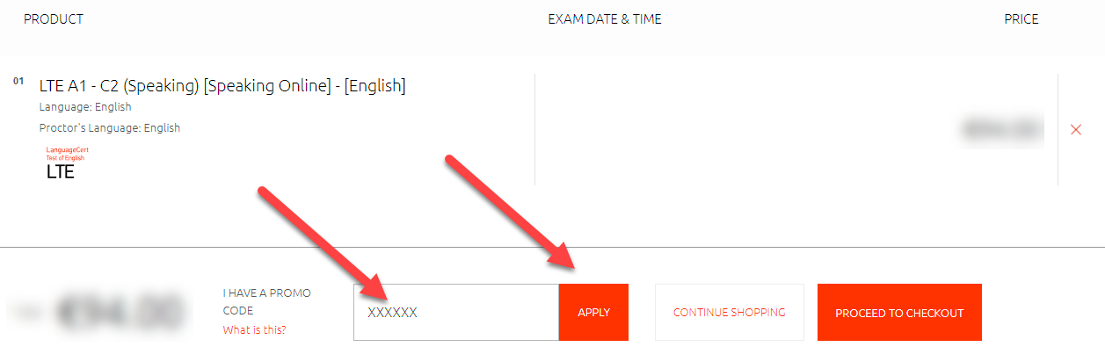
Enter your promo code and click Apply
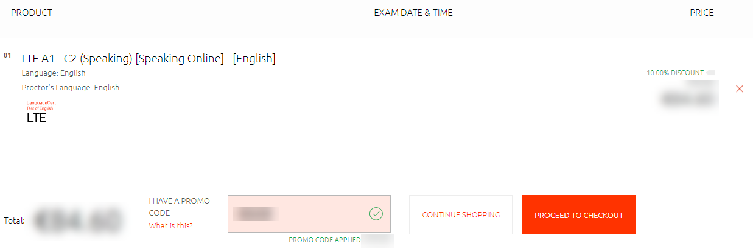
You will see the promo code applied and the discount (which may vary depending on the country our are registering from), click on Schedule or Edit Date & Time

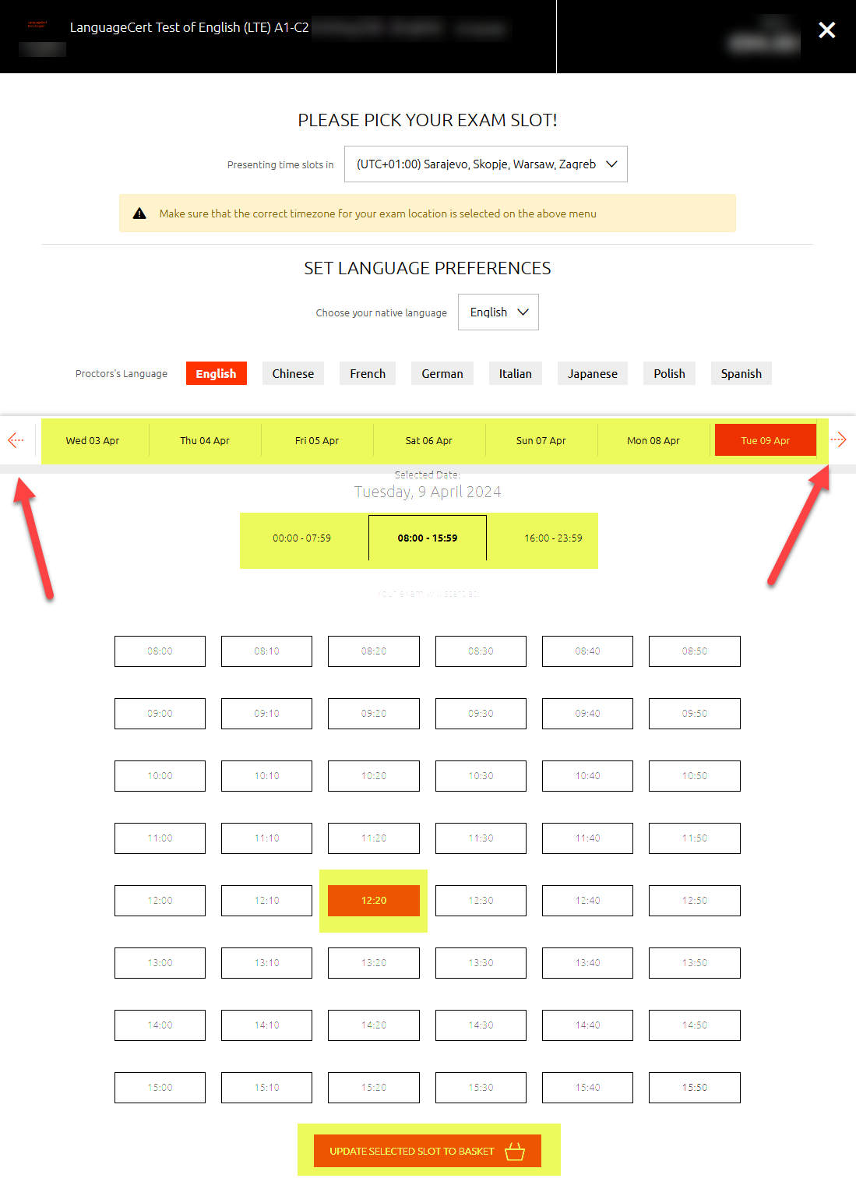

On this page you will be able to:
- Use arrows to select the day of the exam (you have 12 months to decide when to take the exam)
- Select the start time of the exam
- Finalize your selection and proceed to the checkout

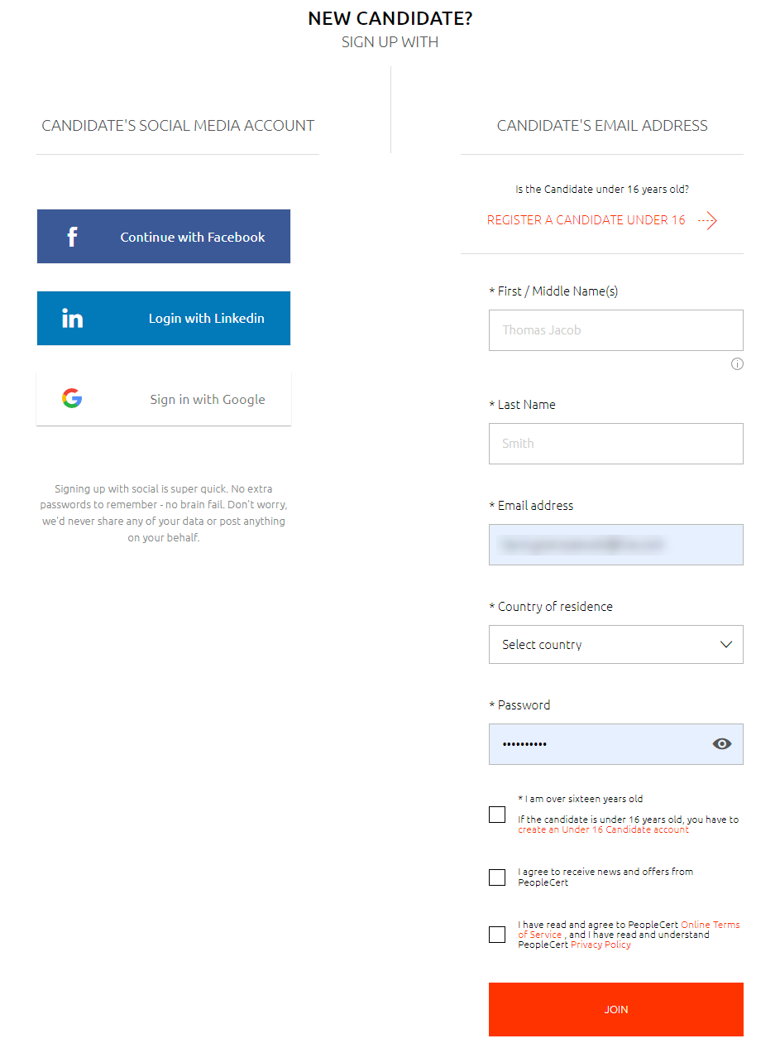
You will be asked to create your candidate’s account, fill in the required fields
The next step will be to complete the payment. You will receive booking confirmation and additional instructions via e-mail.
Tip: When you buy your exam, you will have 12 months from purchase to choose your exam date and time, depending on the availability of the exam slots.

PREPARATION
LanguageCert Test of English (LTE) preparation course!
Speaking Test cracked!
If you're planning to take an Speaking or ESPECIALLY if you're already registered for it, this course is perfect for you.
Your promo code for the course purchase: LAC494 will award you 30% discount!
Click here for the Speaking module preparation course:
https://lynkoacademy.podia.com/lte-speaking
Sample tests, sample exam papers
There are sample tests available on LanguageCert website, you can download the exam packs here: https://www.languagecert.org/en/language-exams/english/languagecert-test-of-english-lte/a1-c2-speaking
… from the Official preparation material section of the website (scroll down on the page and expand).

Prepare your computer for the exam:
For your exam to be conducted successfully, you need to prepare your computer the right way, please see the guidelines below to help you prepare the technical part of the exam experience.
https://www.languagecert.org/en/exam-types/online-exams/olp-guidelines
Tip: Position your camera in such a way that you have the door to your room behind you so that the invigilator can see you and the door behind. Remove all the materials from your desk, put your phone on silent mode in case you will need to be contacted, do not switch it off entirely.
YOUR EXAM SCORES
You will receive a total score from 10 to 100 points. Depending on the number of points, you will see the CEFR level on your Report and Certificate as per below split:
C2 = 90-100 points
C1 = 75-89 points
B2 = 60-74 points
B1 = 40-59 points
A2 = 20-39 points
A1 = 10-19 points
0 = 0-9
WHAT WILL MY CERTIFICATE LOOK LIKE?
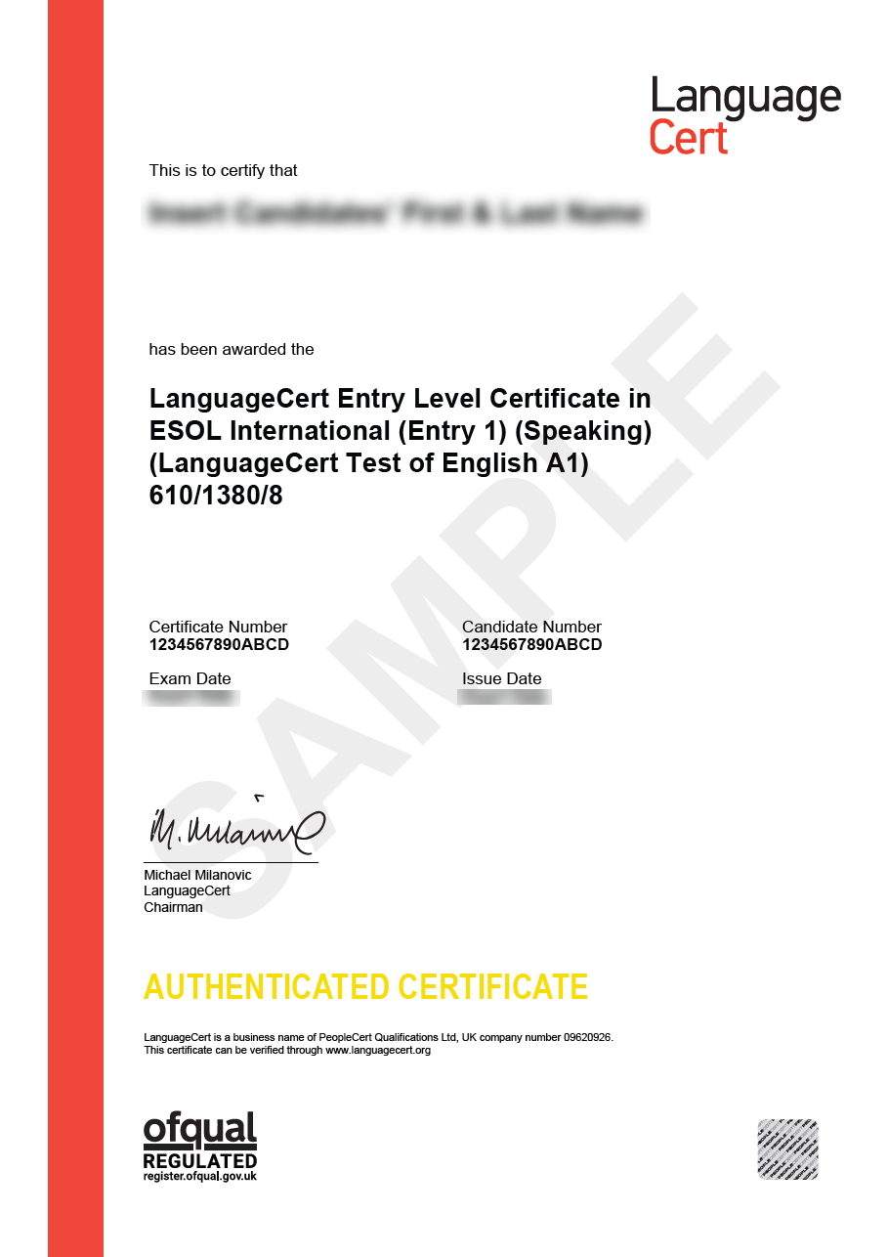

OTHER GREAT EXAM FEATURES

Online administration of the exams – Take LTE at home!
See the introductory clip here: https://youtu.be/E-YBTMH5RZo?si=VUBkAb2KgliKxEDq
Online Live Proctoring means you schedule an appointment with your exam administrator online and connect live to take the exam in a secure and comfortable environment of your own room. With this exam delivery method, you save time and money, you have great flexibility in selecting your exam date and time and you take the exam 1 on 1 with your exam administrator. No need to adjust your schedule to other candidates or test center availability.
Tip:
LTE exam is divided into three modules: Listening & Reading, Speaking and Writing, each offering a separate Certificate. You can decide which one to take first, for example: Listening & Reading is a great start of your journey to get over examination stress and have your first English Certificate. LTE Speaking however, tests the language skill that is often the most desired one in the world of working and communications. LTE Writing addresses a very important skill that you may want to show off to complete your journey with LTE suite of exams, Writing e-mails and chatting in English is now more important than ever!

Digital Badge from LanguageCert to boost your CV and profile!
You will surely impress your interviewer at your new job BUT the idea is to get invited! Adding the LanguageCert digital badge to your CV/resume and to your LinkedIn profile for example will definitely make you more visible in the pool of candidates. Once you pass your LanguageCert LTE, you will find your digital badge on your candidate’s profile, you can share or download your badge and use it to boost your profile!

